**Question 2**

**WebSocket server and Client**

**Develop a WebSocket server and client to facilitate real time bidirectional communication**

Consider a simple system, where users (clients) can send messages to a agent (server) as this will require bidirectional communication we will implement in through WebSocket

**Server Side (Spring Boot WebSocket Server)**

* We configured a WebSocket server (WebSocketSeverConfig.java).
* We created a class MsgWebSocketHandler.java to process WebSocket messages received from client
* "/msg" → This is the **WebSocket URL** (ws://localhost:8080/msg).
* setAllowedOrigins("*") → Allows connections from **any client**

**Client Side (Java WebSocket Client)**

* We created a WebSocket client (WebSocketClientApp.java) that connects to the server.
* The client sends messages and receives responses.

Make the webserver up

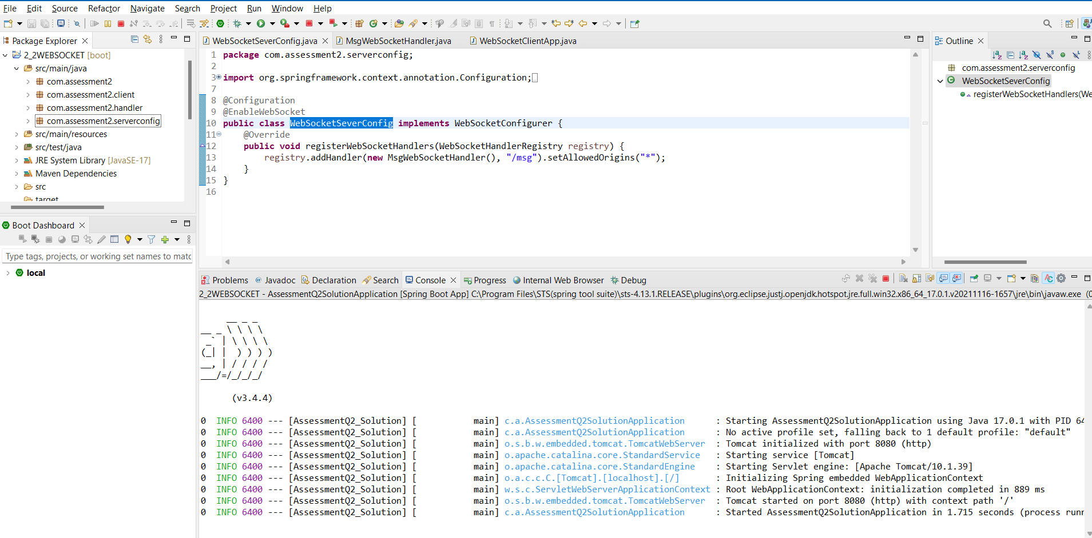

Run the web client

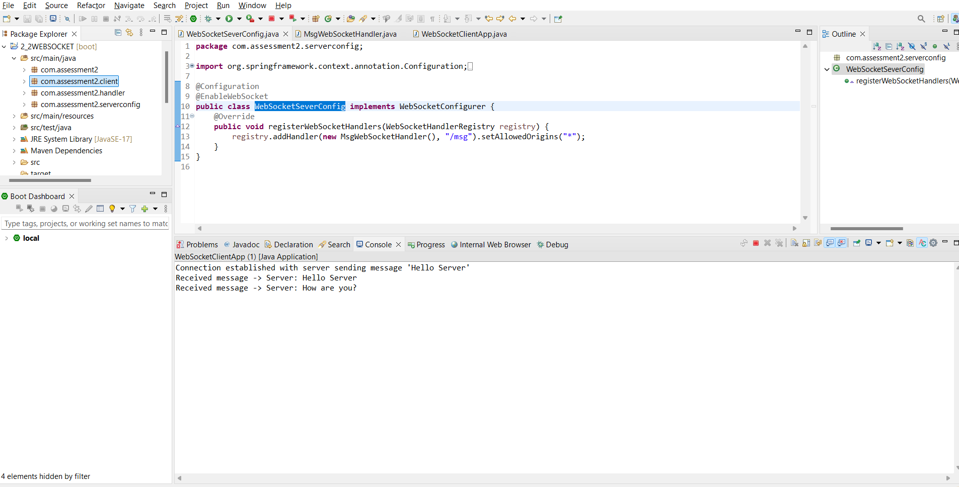

Server console output

